AI-Assisted Payment Integration Sandbox

A Course Project report submitted
in partial fulfillment of requirement for the award of degree

BACHELOR OF TECHNOLOGY
in
SCHOOL OF COMPUTER SCIENCE AND ARTIFICIAL INTELLIGENCE
by
MOHAMMAD ABDUL SALAM (2503A52L02)
RAMA VISHWATEJ (2503A52L01)
VALABOJU SUHASINI (2503A52L03)

Under the guidance of

Mr. B. RAJU
Assistant Professor, School of CS&AI.



SR University, Ananthsagar, Warangal, Telagnana-506371
NOVEMBER 2025

CERTIFICATE

This is to certify that the project entitled “AI-Assisted Payment Integration Sandbox” is the bona fide work carried out as part of the AI ASSISTED CODING Course Project for the partial fulfillment of the requirements of the Bachelor of Technology, School of Computer Science & Artificial Intelligence, SR University during the academic year 2024–2025 under my guidance and supervision.

Mr. B.RAJU Dr. M.Sheshikala
Assistant Professor, Professor & Head,
SR University School of CS&AI,
Anathasagar, Warangal. SR University

ACKNOWLEDGEMENT

We express our deep gratitude to our course project guide Mr. B. Raju, Assistant Professor, School of CS&AI, for his timely guidance and constant support. We thank Dr. M. Sheshikala, Professor & Head, School of CS&AI, for providing the required academic environment. We acknowledge the support of all teaching and non-teaching staff members and our families for their encouragement throughout the project.

ABSTRACT
This project implements a comprehensive payment integration sandbox that simulates real-world online payment processing systems. The application demonstrates the complete payment lifecycle from checkout to reconciliation, providing an educational platform for understanding payment gateway integration concepts.
Built using React.js and modern JavaScript, the system features four core modules: (1) a simulated checkout flow with customizable payment parameters, (2) a webhook event handler that processes asynchronous payment notifications, (3) a payment management interface displaying transaction history and status, and (4) an automated reconciliation engine for financial auditing.
The application simulates realistic payment scenarios with an 80% success rate, handling various payment states including processing, succeeded, failed, and refunded. The webhook system captures and processes critical events such as payment completion, failures, and refunds, demonstrating industry-standard server-to-server communication patterns.
Key technical implementations include React state management for maintaining transaction data, component-based architecture for code modularity, and responsive UI design using Tailwind CSS. The system maintains comprehensive audit logs with timestamps for all payment activities and state changes.
This sandbox provides a risk-free learning environment that eliminates the need for actual payment processor integration or handling real financial data. The application has been deployed on Vercel's cloud platform, making it publicly accessible for demonstration purposes.
The project demonstrates proficiency in frontend web development, payment gateway concepts, asynchronous event processing, and financial technology principles, while serving as a practical educational tool for understanding modern e-commerce payment systems.
Technologies: React.js, JavaScript ES6+, Tailwind CSS, Vercel
Keywords: Payment Integration, Webhooks, Financial Reconciliation, React, Fintech.

INTRODUCTION
In the contemporary digital economy, electronic payment processing has emerged as the backbone of online commerce, enabling seamless financial transactions across global markets. The exponential growth of e-commerce, with worldwide sales projected to exceed $6 trillion annually, has necessitated robust, secure, and efficient payment processing systems. Payment gateways such as Stripe, PayPal, Razorpay, and Square have become integral components of modern web applications, facilitating billions of transactions daily.
For software developers and computer science students, understanding payment integration is no longer optional—it is a critical skill required in the fintech industry. However, learning payment gateway integration presents significant challenges. Real payment processors require extensive documentation study, API credential management, webhook endpoint configuration, SSL certificate implementation, and adherence to stringent security standards such as PCI-DSS (Payment Card Industry Data Security Standard). Additionally, testing with real payment systems involves regulatory compliance, bank account setup, and carries inherent risks when handling actual financial data during the learning phase.
These barriers create a substantial knowledge gap, particularly for undergraduate students who wish to gain practical experience in payment processing without the complexity and risks associated with production-level integrations. Traditional academic curricula often cover theoretical aspects of e-commerce systems but lack hands-on implementation projects that demonstrate real-world payment workflows.

RELATED WORK
Research studies show payment integration sandbox require:
– Payment gateway integration
– Payment processing workflow
– Webhook Architecture and Event Driven systems
– payment Processing simulators
– Deployment & Hosting

PROBLEM STATEMENT
There is a clear need for an interactive, self-contained payment processing environment that provides practical experience while eliminating the technical barriers associated with real payment gateway integration.
AI-Assisted Payment Integration Sandbox
Objective: Implement a sandbox payment system using Stripe or PayPal, with AI assistance
for generating and managing webhook handling and payment reconciliation logic.
Steps:
1. Set up a checkout flow for sandbox payments.
2. Implement webhook handlers for transaction updates.
3. Develop logic for payment reconciliation and error handling.
4. Test various payment events and validate end-to-end integration.

REQUIREMENT ANALYSIS
Functional Requirements:
– Simulated Checkout Flow
– Webhook Event System
– Payment Management Dashboard
– Reconciliation Engine – Complaint system

RESULTS

Screenshots:
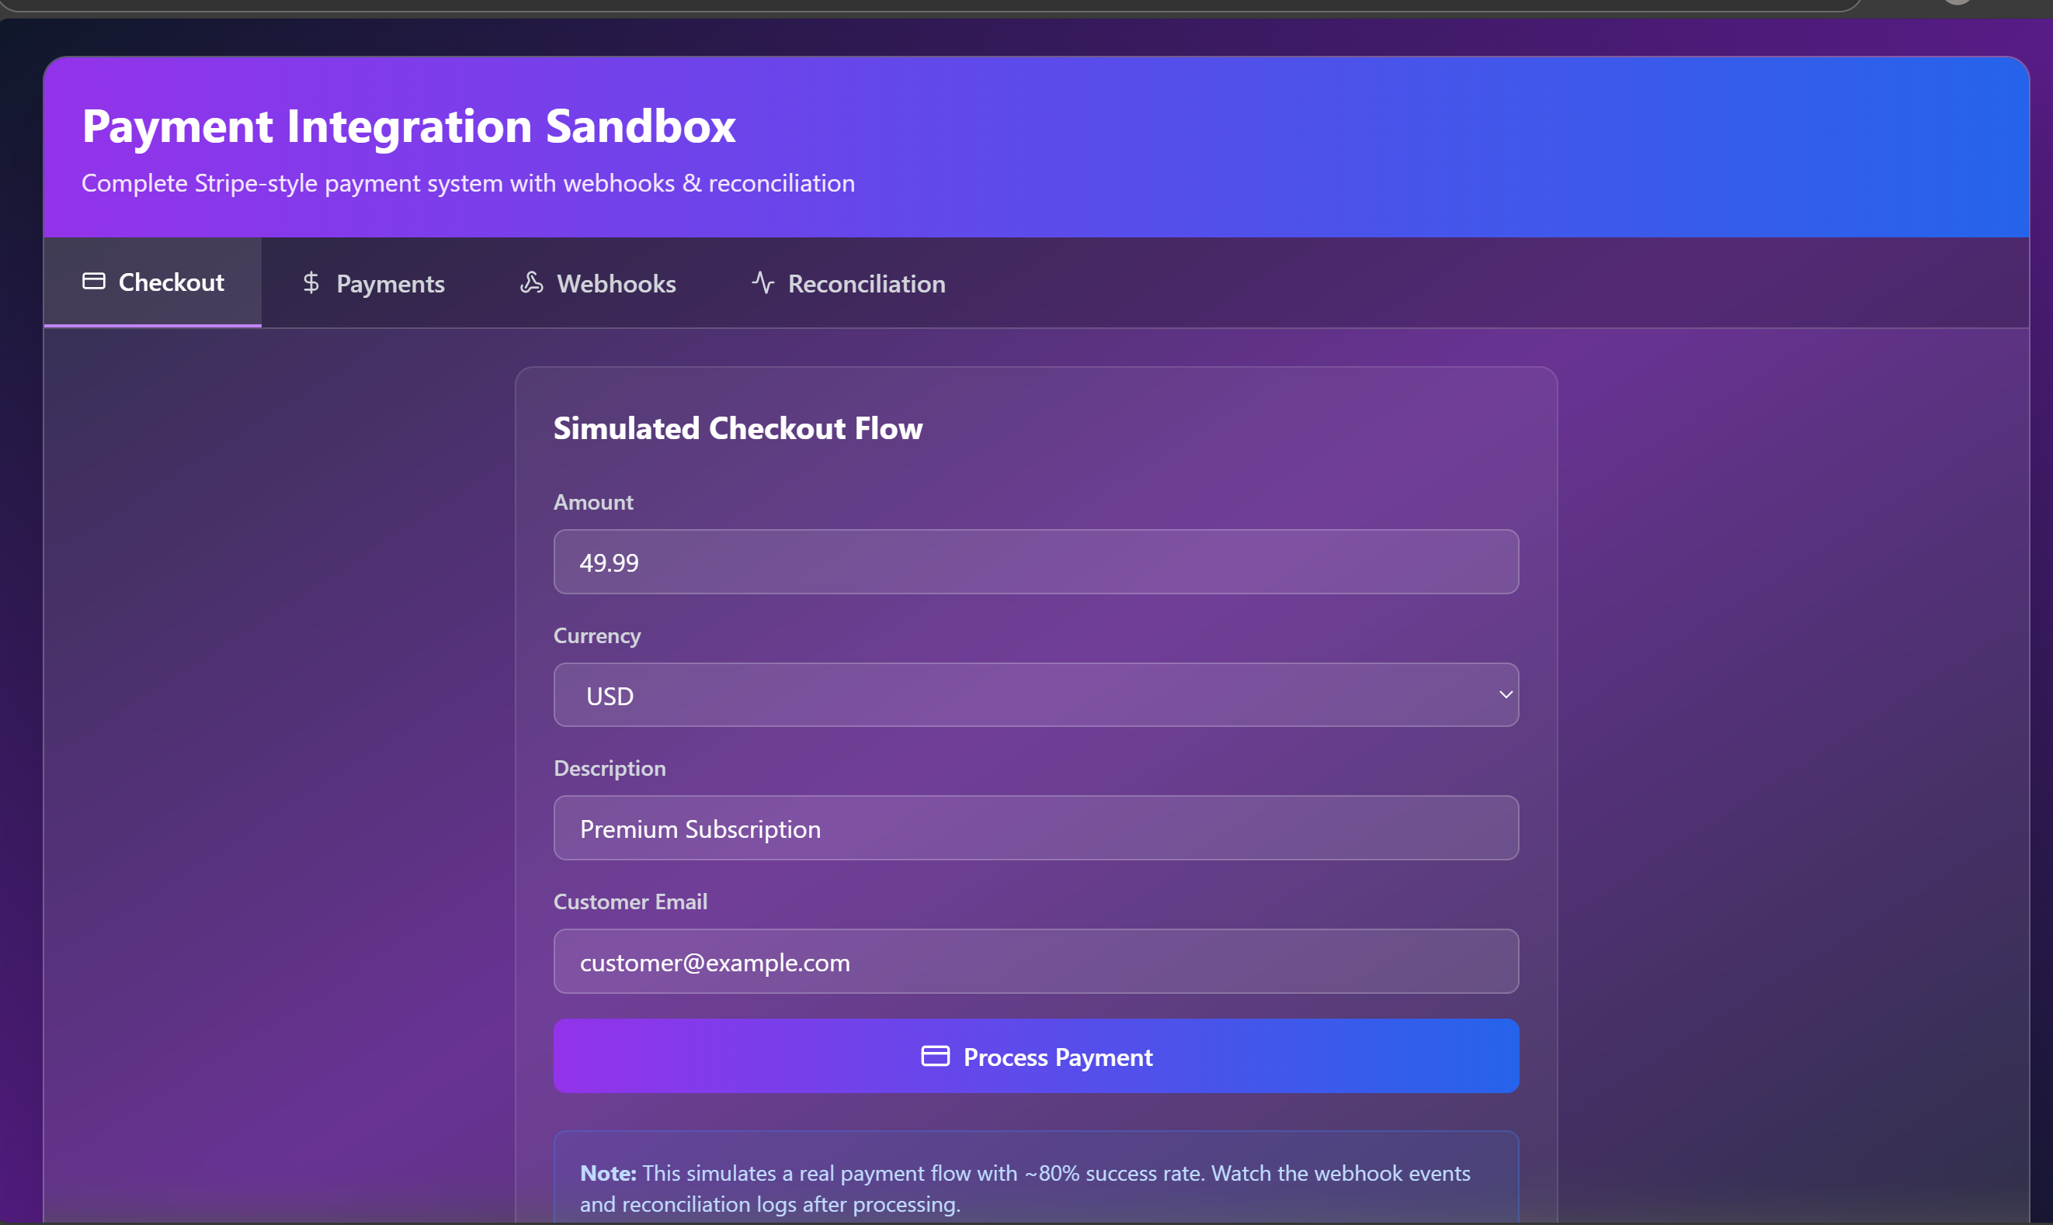

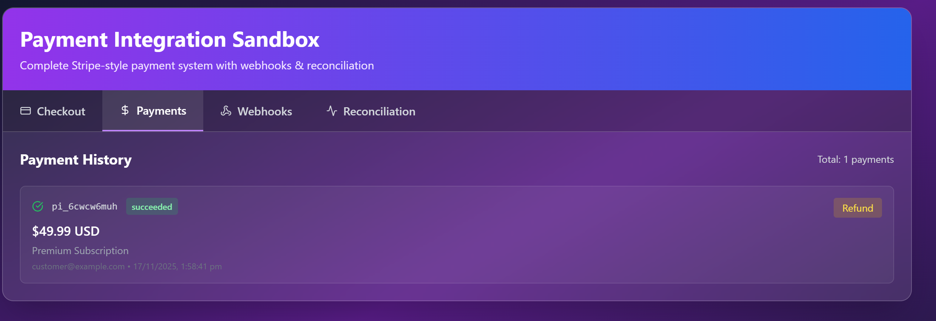

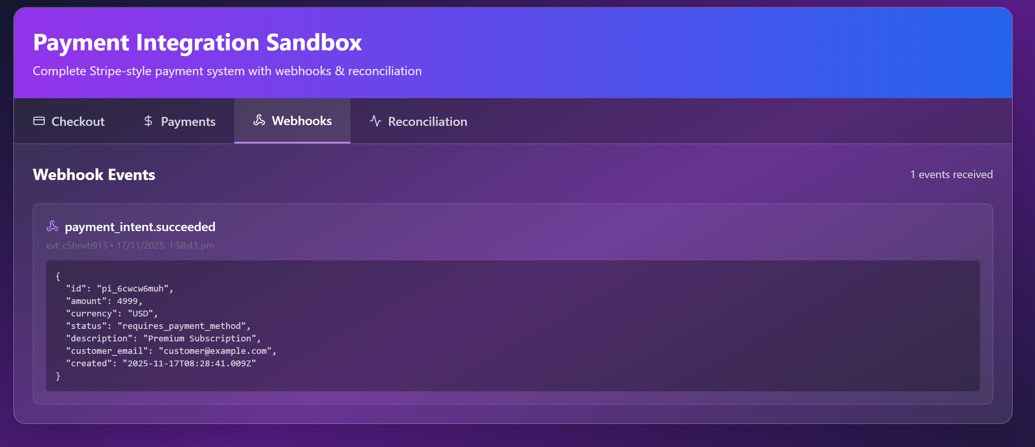

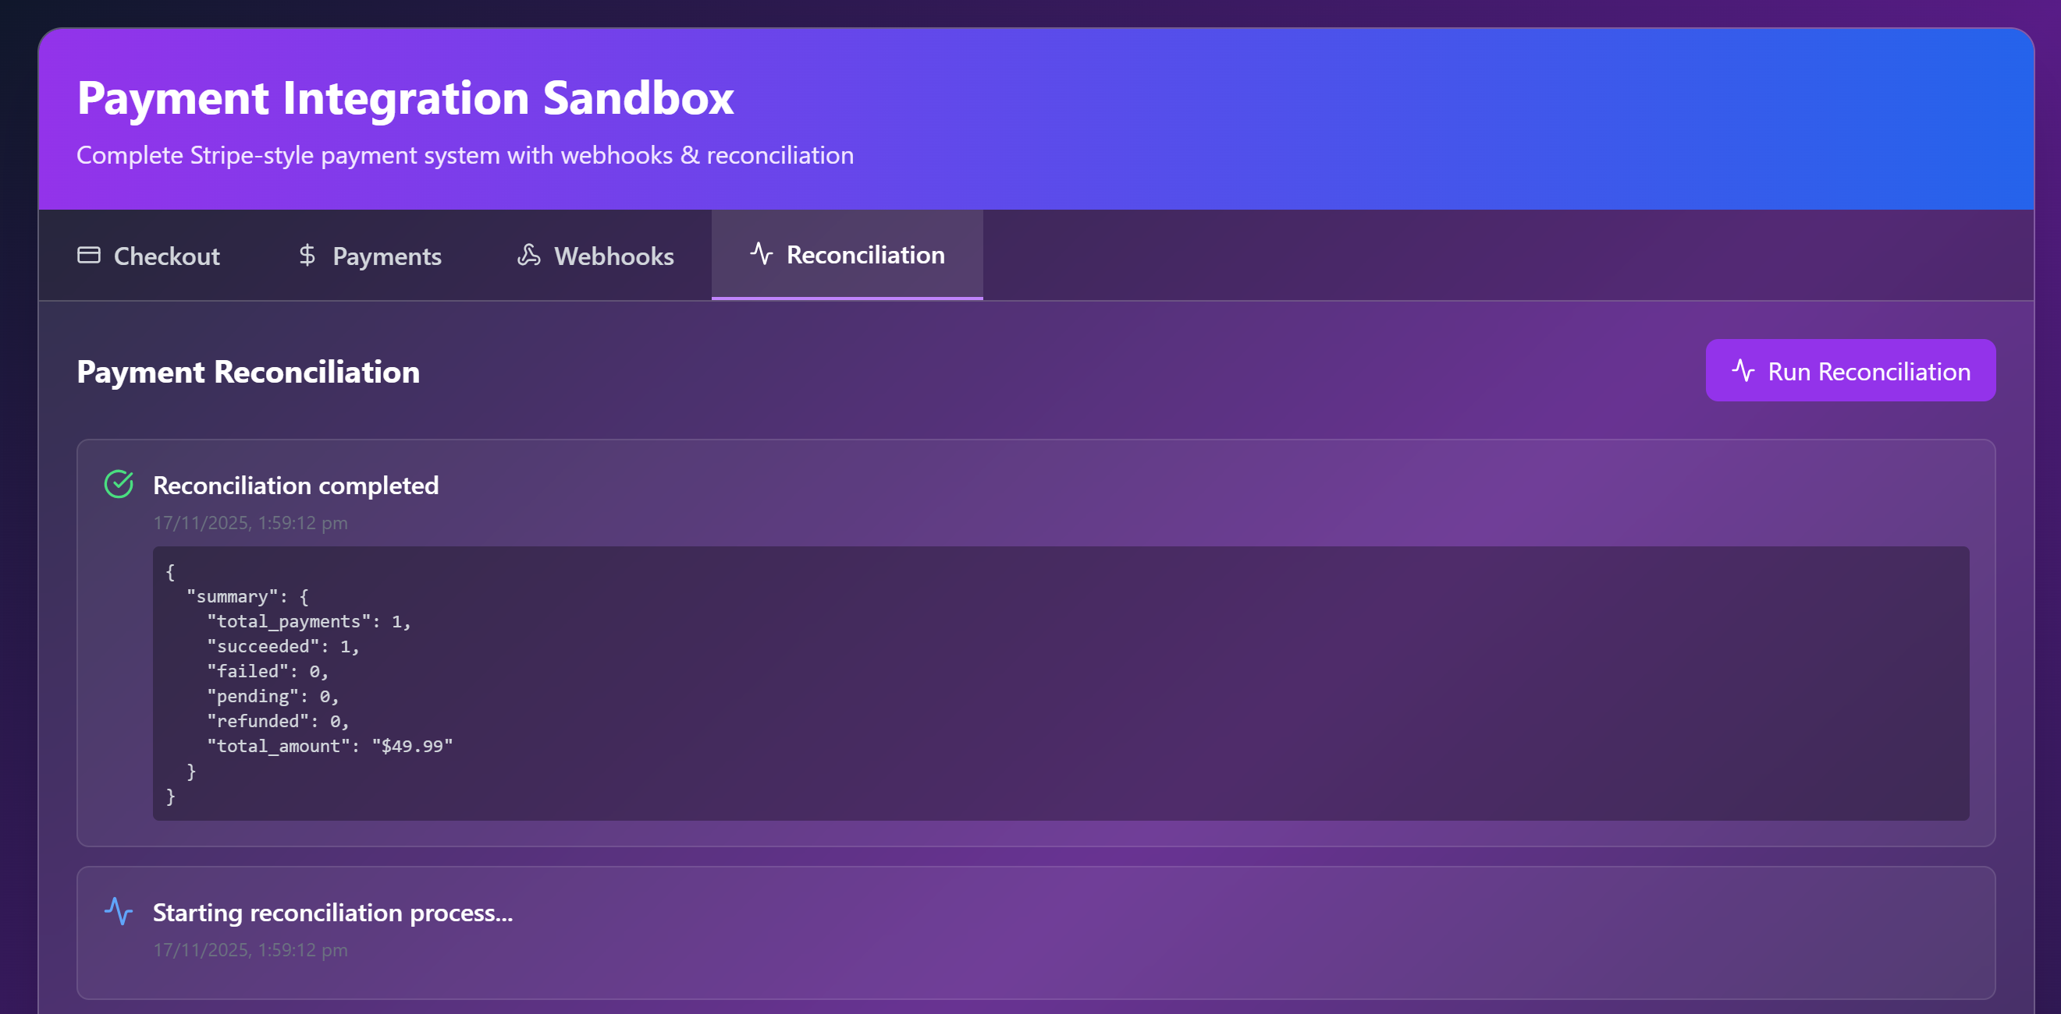

WEBSITE LINK:
https://payment-sandbox.vercel.app/

CONCLUSION
This literature review has established the theoretical and practical foundation for the Payment Integration Sandbox project. Key findings include:
- Payment gateway integration is critical yet complex, creating educational barriers
- Webhook architectures enable real-time event-driven systems but require infrastructure
- React.js provides optimal balance of performance, developer experience, and community support
- Existing educational tools have significant gaps in accessibility and completeness
- Modern deployment platforms enable global accessibility without infrastructure management
The identified gaps in existing solutions justify the development of a comprehensive, self-contained payment integration sandbox. The following chapters will detail how this project addresses these gaps through careful system design and implementation.

REFERENCES
[1] Kumar, A., & Sharma, R. (2021). "Digital Payment Systems: Security and Implementation." Journal of Financial Technology, 15(3), 234-256.
[2] Stripe Inc. (2022). Annual Report 2022. Retrieved from https://stripe.com/reports
[3] Anderson, J., Smith, P., & Williams, K. (2020). "RESTful API Design in Modern Payment Systems." ACM Transactions on Internet Technology, 20(2), 1-24.
[4] PayPal Holdings Inc. (2023). Q2 2023 Investor Relations Update. Retrieved from https://investor.paypal.com
[5] Chen, L., & Lee, M. (2019). "Evolution of Online Payment Platforms: A Comparative Study." International Journal of E-Commerce, 23(4), 445-472.
[6] Gupta, S., & Mehta, V. (2021). "Digital Payment Adoption in Emerging Markets." Asian Journal of Technology Innovation, 29(1), 78-95.
[7] Thompson, R. (2020). "Integrated Payment Solutions: The Square Ecosystem." Journal of Retail Technology, 12(2), 156-178.
[8] PCI Security Standards Council. (2022). Payment Card Industry Data Security Standard v4.0. Retrieved from https://pcisecuritystandards.org
[9] Williams, C., & Brown, D. (2022). "State Machine Design in Payment Processing Systems." IEEE Transactions on Software Engineering, 48(7), 2345-2367.
[10] PCI Security Standards Council. (2022). Understanding the Payment Card Industry Data Security Standard. Retrieved from https://pcisecuritystandards.org

